Homework Assignment number 2.

Chap 10.

2. a. The most obvious answer that is thought of is that as MJ use increases, GPA declines. But, suppose that as GPA declines, one begins to use MJ as a “relaxant”. In the latter case, a GPA decline causes MJ use.

b. How about inquisitiveness or curiosity as a personality trait? Persons who tend to be higher in curiosity might also be more likely to get GPA’s and to experiment with a mind-altering substance.

3. How about the positive correlation murder rate and the number of people owning guns? Do more people buy guns and then the murder rate goes up? Or do more people buys guns as the result of an increase in the homicide rate?

4. First, to control for a variable means to keep its value constant while studying the association between two other variables. As we saw in class, the association between height and achievement will change dramatically after controlling for age.

5. A spurious association exists when two variables are jointly caused by a third variable; when the third variable is controlled for, the previous unconditional association is gone.

a and b. The scatterplot showing height and achievement controlling for age is the same as the scatterplot for the variables shoe size (height), age (age), and number of books one has ever read (achievement).

6. Per Capita GNP could influence both birth rate and TV ownership. Higher values of GNP tend to occur with both lower birth rates and higher levels of electronic ownership. Perhaps people are too busy watching TV to make a baby ☺.

9. Perhaps both are affected by a persons’ Socioeconomic Status (SES). We should compare the mean math scores for the two groups at fixed levels of parents’ SES by regressing math grades on SES, and assessing the magnitude of the coefficient of the difference between the two groups after residualizing the effect of SES from grades.

10.

a. The number of years since PhD is + correlated with salary. Salary is also positively related with years of employment, as is the likelihood of being male. Therefore, salary discrepancies between males and females may be due to age differences; when controlling for age, they may disappear.

b. This one is obvious. More males are in the higher salary departments; controlling for department should control for salary discrepancies.

c. Gender ➔ years experience ➔ Salary.

11. Size of home is + correlated with selling price and number of bedrooms. It overlaps with # bedrooms in explaining variation in price. Fixing the size of the home, by increasing the number of bedrooms, one necessarily decreases the size of the other rooms (kitchen, living, etc)., thus the effect of number of bedrooms does not have a very strong effect. Number of bedrooms has a direct effect on selling price, and an indirect effect through the size variable.

size
#bed
price
14. Let A = attitude about legal abortion, R = Religiosity, and S = Sexual Attitude

Diagram 1 and 2 R ➔ S ➔ A or R ➔ A

S

In 1 – Religiosity influences sexual attitudes, which in turn influences abortion attitudes.
In 2 – Religiosity is a direct influence on Abortion, but is moderated by sexual attitudes.

Chapter 11.

1. a. Positive, since crime ↑ as income ↑.

b. Negative, since controlling for percent urban, the trend appears negative.

c. y^ = -11.5 + 2.6X; the predicted crime rate increases by 2.6 (per 1000 residents) for every thousand dollar increase in median income.

d. y^ = 40.3 - .81*x1 + .65*x2; the predicted crime rate decreases by .8 (per 100 residents) fpr each 1000 dollar increase in median income, controlling for level of urbanization. Compared to c, the effect is weaker and is in a different direction. This is an example of Simpson’s paradox.

e. Because urban is highly positively correlated with both income and crime. When considering the residualized effect, the association is weaker.

f. At Urban = 0 ➔ y^ = 40.3 - .81*x1
At Urban = 50 ➔ y^ = 40.3 - .81*x1 + .65*(50) = 73 - .81*x1
At Urban =100 ➔ y^ = 40.3 - .81*x1 + .65*(100) = 105 - .81*x1

The slope for crime is constant for varying levels of urban, but the intercept changes, suggesting that crime rate are higher for increasing levels of urbanization. That is, you get parallel lines which could be graphed at these three levels.

2. a. (i) E(Y) = .2 + .5(4) + .002(800) = 3.8; (ii) 2.3

b. E(Y | x2 = 500) = .2 + .5*x1 + .002(500) = 1.2 + .5*x1

c. E(Y | x2 = 600) = .2 + .5*x1 + .002(600) = 1.4 + .5*x1

E(Y|x2=600) – E(Y|x2=500) = 1.4 - 1.2 = .2 which is 100*β2

d. Just graph 3 lines of E(Y | x2 = k) for three different values of k.

e. No, the two different variables have different metrics.

9. a) Y^ = 135.3 - 14.07*x1 - 2.95*x2; -14.07 = change in expected feelings toward liberals for a 1 unit change in political ideology (becoming more conservative) , all other things being equal (e.g. religious attendance); -2.95 = change in expected feelings toward liberals for a 1 unit change in religious attendance (increasing attendance), all other things being equal (e.g. political ideology).

b. Y^ = 135.3 - 14.07*7 - 2.95*9 = 10.3; residual = 10 – 10.3 = -.3.

c. PRE =.799. When compared to a baseline model fitting only the mean of feeling toward liberals, PRE = .799 indicates the proportional reduction in residual error obtained by fitting a model using ideology and religious attendance to explain feelings toward liberals. Or, there is an 80% reduction in error when predicting Y using X1 and X2 instead of Mean(Y).

d. For ideology, Wald t = -14.07 / 3.16 = -4.45; P(|t| > t-crit(df = 7)|H0) is less than .01.

So, you get the two stars. It is always better to report the actual p-value - or even better, the CI. For instance, a p < .049 is practically no different than a p , .051. Yet, the former gets a star, the latter doesn’t. This is a very bad practice of using stars.

e. Use the GLM formula; F* = [pre / (1 – pre)] * df(r) – df(f) / df(f) .

f. Ideology appears to have a stronger partial effect than religious attendance; for a 1 SD increase in ideology, you get a -.79 SD change in feelings, versus only a -23 SD change in feelings for rel. attendance.

11.

Data one;
input price size bed bath new;
cards;
48.5 1.10 3 1 0
55.0 1.01 3 2 0
68.0 1.45 3 2 0
137.0 2.40 3 3 0
309.4 3.30 4 3 1

proc reg corr;
model price = size bed bath / r scorr1 pcorr2 stb;
plot r.*size ;
plot r.*bed;
plot r.*bath;
plot r.*p.; * residual by fitted value *;
run;

proc reg corr;
model price = bed bath / r scorr1 pcorr2 stb;
plot r.*bed;
plot r.*bath;
plot r.*p.; * residual by fitted value *;
run;

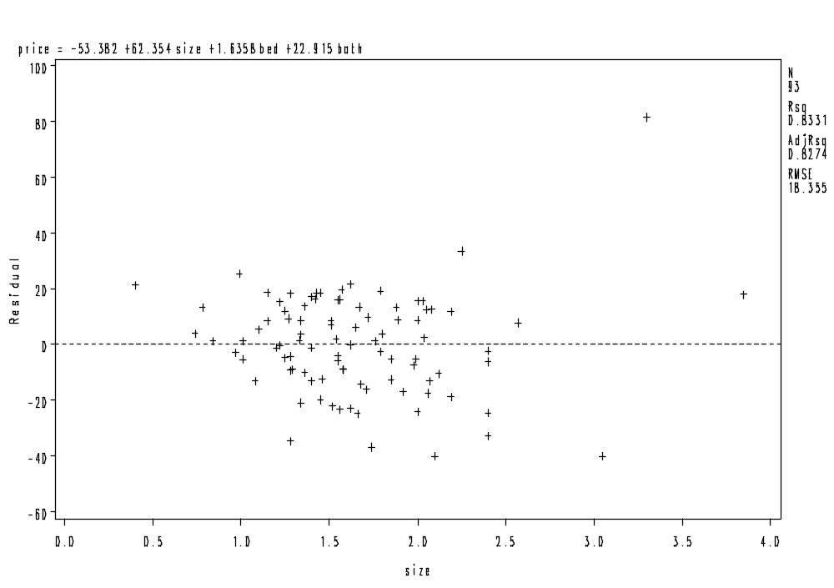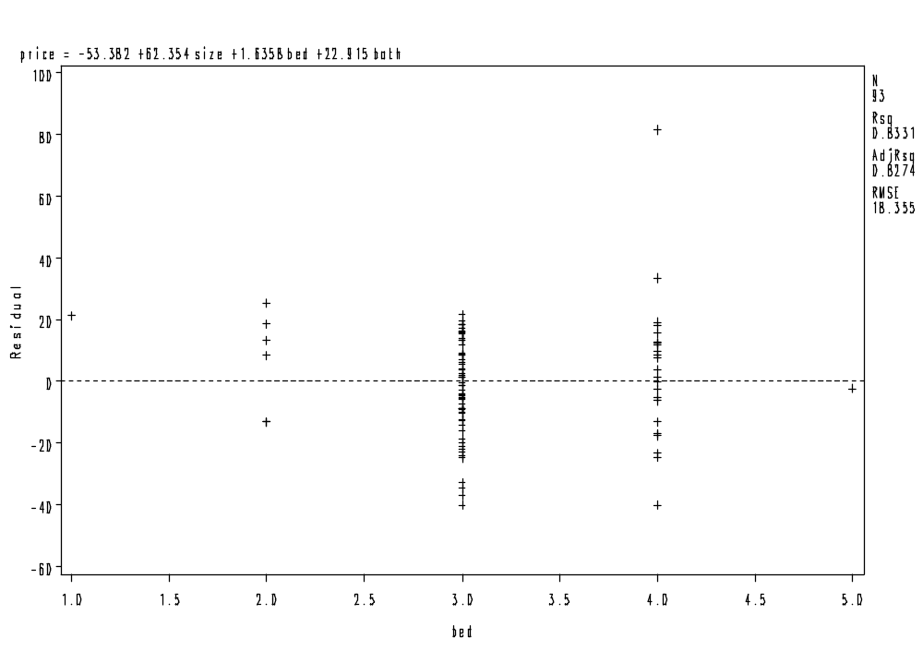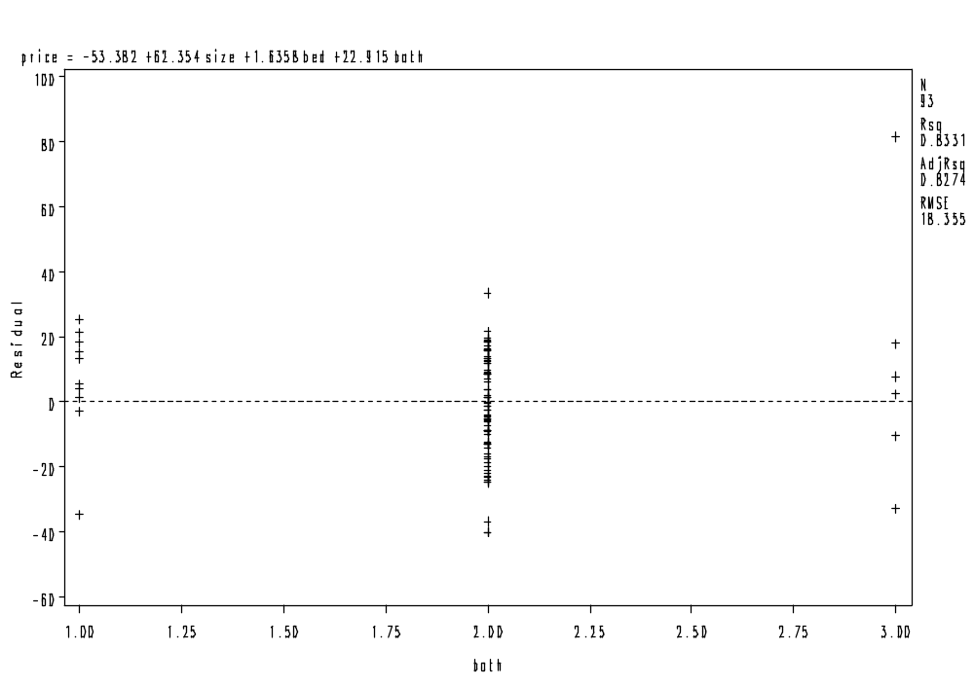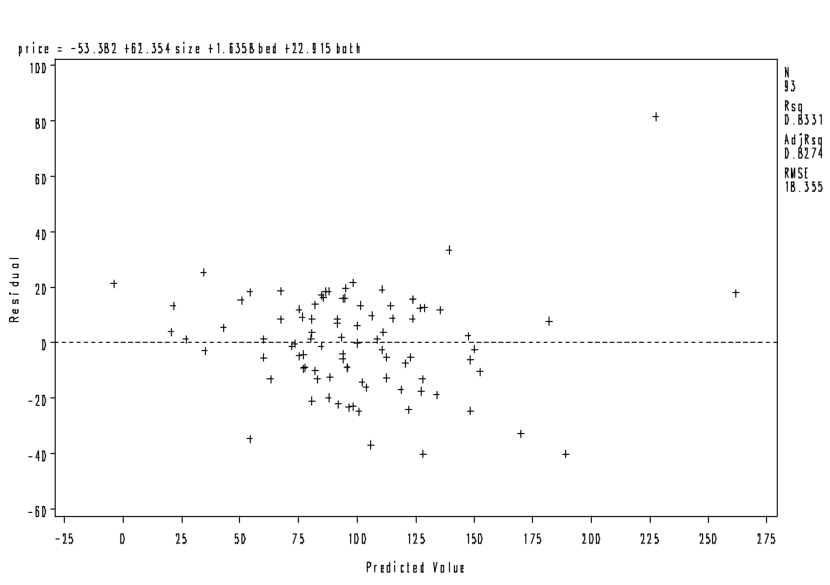

b. Analysis of Variance

Sum of Mean
Source DF Squares Square F Value Pr > F

Model 3 149621 49874 148.03 <.0001
Error 89 29985 336.90628
Corrected Total 92 179606

Root MSE 18.35501 R-Square 0.8331
Dependent Mean 99.53333 Adj R-Sq 0.8274
Coeff Var 18.44107

Parameter Estimates

Squared Squared
Parameter Standard Semi-partial Partial
Variable DF Estimate Error t Value Pr > |t| Corr Type I Corr Type II

Intercept 1 -53.38249 13.31866 -4.01 0.0001 . .
size 1 62.35406 6.29202 9.91 <.0001 0.80787 0.52459
bed 1 1.63579 4.32699 0.38 0.7063 0.00022474 0.00160
bath 1 22.91548 6.28175 3.65 0.0004 0.02496 0.13007

yhat = 123.8

c. Correlation

Variable size bed bath price

size 1.0000 0.6691 0.6625 0.8988
bed 0.6691 1.0000 0.3338 0.5903
bath 0.6625 0.3338 1.0000 0.7137
price 0.8988 0.5903 0.7137 1.0000

d. pre = .83.

e. Use GLM formula, using either the E(R) and E(F) notation, or PRE.

f. Use the Wald formulation: t = b / se(b).

g. Analysis of Variance

Sum of Mean
Source DF Squares Square F Value Pr > F

Model 2 116534 58267 83.14 <.0001
Error 90 63072 700.79663
Corrected Total 92 179606

Root MSE 26.47256 R-Square 0.6488
Dependent Mean 99.53333 Adj R-Sq 0.6410
Coeff Var 26.59668

Parameter Estimates

Squared Squared
Parameter Standard Semi-partial Partial
Variable DF Estimate Error t Value Pr > |t| Corr Type I Corr Type II

Intercept 1 -113.47323 17.10265 -6.63 <.0001 . .
bed 1 28.84045 4.82388 5.98 <.0001 0.34842 0.28426
bath 1 61.93867 7.05887 8.77 <.0001 0.30042 0.46106

Big difference in interpretation now.

h. What is the difference in price between a 1 and 2 bedroom home? $28.8 thousand dollars, controlling for number of bathrooms.

i. 28.84 +/- (1.96*4.83) = [19.3,38.4]. This is the 95% CI for the change in average price for an increase of 1 bedroom, controlling for the number of bathrooms.

j. pcorr = .53; corr = .59. Not much different – why?

k. stb(x) = b * sd(x) / sd(y). stb = .39 for bed, and .58 for bath.

l z(y^) = .39*z_bed + .58*z_bath.

14. BR = Birth Rate. ECON – Female economic activity LITER - Literacy Rate

BR - number of births per 1000 population size

ECON – Percentage of females working as a percentage of men working

LITER – percentage of females who are literate

a. 1. r(BR, ECON) = -0.61 2. r(BR,LITER) = -0.81 3. r(ECON,LITER) = .42

4. TSS = E(R) = 2411.93 5. SSE = E(F) = 585.24 6. MSE = 29.27

7. σ^ = RMSE = 5.410 8. sd(y) = 10.47 9. σ^(β1) = 0.0640

10. t for H0: β1 = 0 ➔ -2.676 11. P for H0: β1 = 0 vs H0: β1 ≠ 0 ➔ .0145

12. for H0: β1 = 0 vs H0: β1 < 0 ➔ .0145 ÷ 2 = .0073

13. F for H0: β1 = β2 = 0 ➔ 31.19

14. P for H0: β1 = β2 = 0 ➔ 0.0001

15. df for σ^ = 20 16. P for H0: ρ(BY,ECON) ➔ .0019

b. E(BR) = 61.713 – 0.171 * econ - 0.404*liter

Intercept = The expected BR is 61.713 births per 1000 population in countries where NO females work and ALL females are illiterate.

ECON – For each additional 1% (absolute) increase in the female population working (when compared to men), we can expect about 0.171 fewer births per 1000 population, holding literacy rate fixed across countries.

LITER – For each additional 1% (absolute) increase in the female literacy rate, we can expect a 0.404 decrease in the birth rate per 1000 population size, with labor force occupation held constant across countries.

c. They are unconditional correlations between BR and the two predictors, ECON and LITER. They are both strongly negative.

d. PRE = r²(Y,Y^) = .76. This model strongly reduces the prediction error when compared to no model at all.

e. Multiple r = sqrt(PRE) = .87. This means that a very strong linear association exists between the fitted values from the regression model and the actual birth rates.

f. F* = Δfit / E(F) * df(F) / Δdf F(2,20) = 31.191, P< .0001.

g. Use the Usual Wald formulation of t = β^ / se(β^).

17.

a. For X2 = 1 (new), then E(Y) = - 6.502 + 72.575 * size
For X2 = 0 (old), then E(Y) = -26.089 + 72.575 * size

b. Because E(Y|new,size) - E(Y|old,size) gives the mean difference in selling price holding size constant.

c. t = 4.903, p < .0001. This suggests that there is a $19,575 difference between the selling price of a new versus old house, controlling for house size. This result appears to be unlikely to be due to a chance occurrence.

d. Assuming n is large enough, then β +/- 1.96 * se( β) ➔ 19.587 +/- 1.96 * 3.995

18.

a. E(Y) = -16.60 – 31.83 * new + 66.61 * size + 29.39 * newsize

E(Y) = β0 + β1 NEW + β2 SIZE + β3 NEW*SIZE

IF NEW = 1 (yes) then

E(Y) = β0 + β1 + β2 SIZE + β3 SIZE

= (β0 + β1) + (β2 + β3) SIZE

so, E(Y) = - 48.43 + 96 * Size

IF NEW = 0 (no) then

E(Y) = β0 + β2 SIZE

so, E(Y) = - 16.60 + 66.61 * Size

Interpretation: We see a huge difference between the influence of size on the selling price of a house depending upon whether it is a new or old house. For new houses, each 1000 additional square feet predicts a $96K increase in the selling price, whereas for old houses, each 1000 additional square feet predicts only a $66.6K increase in the selling price – that is a difference of about $30k.

b. Predicted Values of selling price for: :

New House Old House

Sq. ft = 1.5K 95.57 83.32
Sq. ft. = 2K 143.57 116.62

Sq. ft. = 2.5K 191.57 149.93

We can see that for a given size house, NEW houses ALWAYS sell for more, but that the difference in sales price between NEW and OLD houses gets LARGER as the size of the house increases. In fact, for each additional 500 sq ft, the EXPECTED DIFFERENCE between a NEW and OLD house sales price rises by 29.39 / 2 or an additional $14.7K dollars.

c. β^ = 29.392, se(β^) = 8.195 t = 3.587, p < .0005. There is a statistically significant interaction between the size of a house, the age of a house, and its selling price.

d. When the outlier is removed, the effect of the interaction is no longer statistically significant.

19. Yes, the positive coefficient for the x1*x2 interaction effect means that we see a increase in the slope for X1 as X2 increases.

22.

a. Using the bivariate formulation of partial correlation, we note that

r(yx1.x2) = r(y,x1) - r(y,x2)*r(x2,x1) / SQRT [(1 – r²(y,x2)) (1 – r²(x1,x2))]

So, we have

pcorr(y,x1) = .65 – (.85)(.75) / sqrt [(1 - .72)(1 - .56)]

= .65 - .64 / sqrt[.12] = .01 / .35 = .028

The partial correlation between vocabulary and height, controlling for age, appears to be very small.

b. To test pcorr(y,x1), from Agresti form the following t statistic:

t = pcorr / sqrt [ (1 – pcorr²) / n – p]

so t = .028 / sqrt [999/ 100 - 2] = .028 / .101 = 0.28 . NS

c. Yes, This is the example we gave in class.

23.

a. It is not possible to tell from the regression coefficients since the variables are measured in different units.

b. all standardized betas are calculated as follows: sd(Xi) / sd(Y) * β

For example, stb(X2) = -.1 * 10 / 8 = -.125.

c. E(z-y) = -.075*z1 -.125*z2 -.30*z3 +.20* z4

For a city that is 1 SD above the mean on number of police officers, median length of sentencing for convicted murderers, and median income, and 1 SD below the mean on unemployment, we expect a -.7 SD decline in the murder rate.

27. SAS CODE FOLLOWS:

proc reg;
model vr = s m / stb pcorr2;
plot vr*p.;
plot r.*s r.*m;
run;

data two; * get rid of problematic outlier *;
set one;
if state = 'DC' then delete;
run;

proc reg;
model vr = s m / stb pcorr2;
plot vr*p.;
plot r.*s r.*m;
run;

OUTPUT From 1st analysis with plot of actual by fitted values

Analysis of Variance

Sum of Mean
Source DF Squares Square F Value Pr > F

Model 2 7955396 3977698 107.68 <.0001
Error 48 1773079 36939
Corrected Total 50 9728475

Root MSE 192.19560 R-Square 0.8177
Dependent Mean 612.84314 Adj R-Sq 0.8101
Coeff Var 31.36130

Parameter Estimates

Squared
Parameter Standard Standardized Partial
Variable DF Estimate Error t Value Pr > |t| Estimate Corr Type II

Intercept 1 -1622.01136 154.98650 -10.47 <.0001 0 .
S 1 155.52813 13.26760 11.72 <.0001 0.74802 0.74112
M 1 7.02509 1.28191 5.48 <.0001 0.34970 0.38487

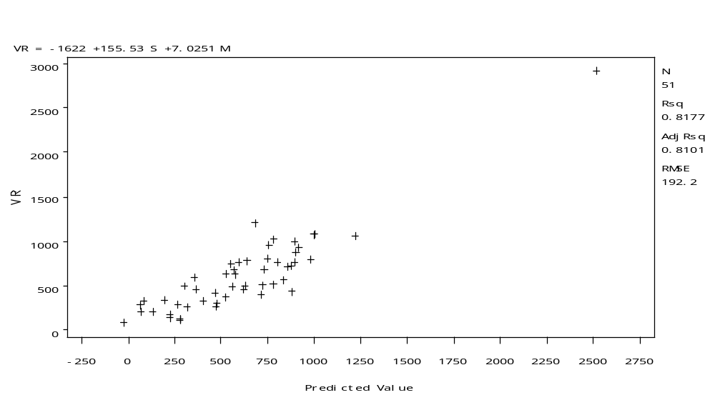
It is possible that the DC outlier is “artifactually” making the correlation bigger than it should be because it is so far out of lime with all other observations.

After dropping DC and re-fitting:

Analysis of Variance

Sum of Mean
Source DF Squares Square F Value Pr > F

Model 2 2868932 1434466 47.46 <.0001
Error 47 1420693 30228
Corrected Total 49 4289625

Root MSE 173.86060 R-Square 0.6688
Dependent Mean 566.66000 Adj R-Sq 0.6547
Coeff Var 30.68164

Parameter Estimates

Squared
Parameter Standard Standardized Partial
Variable DF Estimate Error t Value Pr > |t| Estimate Corr Type II

Intercept 1 -1161.30315 194.58480 -5.97 <.0001 0 .
S 1 114.17949 17.05004 6.70 <.0001 0.56926 0.48827
M 1 6.88407 1.16036 5.93 <.0001 0.50431 0.42820
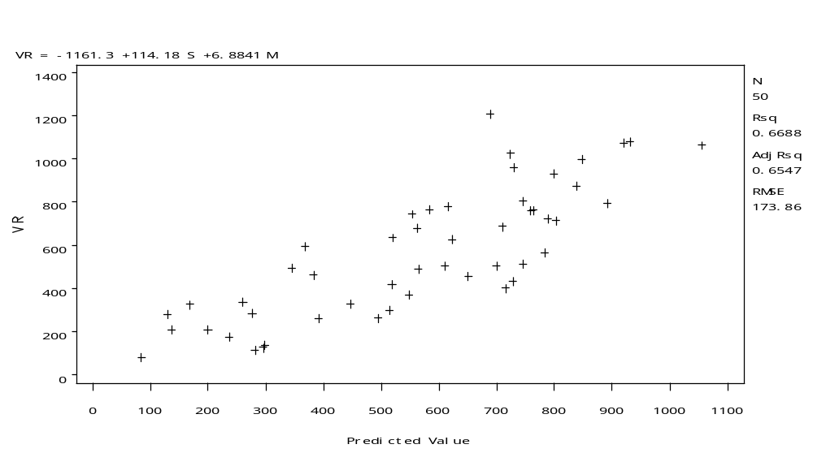
Both graphical evidence and descriptive data are better behaved when considering DC to be an outlier. The results of the regression modeling are based on the following analysis. We fit a regression model containing two explanatory variables: percentage of single-parent families, and percentage living in metropolitan areas. The response variable of interest was rate of violence (per 100k population). The regression analysis was conducted on a sample size of n=50 states.

A preliminary model fit quite well (PRE = .82), but visual inspection of the plot of actual values versus fitted values suggested that DC was a possible outlier and was creating a circumstance in which the value of the PRE was most likely too large because of the DC effect.

When the model was re-fitted without the DC observation, the fit declined (PRE= .66), but subsequent graphical inspection of the residual plots showed no obvious problems with the model or the rest of the data.

As for the analysis, the overall fitted 2-variable regression model was statistically significant, F(2,47) = 47.4, p < .0001, with PRE = .66 and RMSE = 173.86. The parameter estimates for both the single-parent effect, β=114.7, SE=17.05, t=6.7, p< .0001, and for the metro area effect, β=6.88, SE=1.16, t=5.93,p<.0001, were also statistically significant.

The model suggests that for a 10% absolute increase in the percentage of single-parent families, we can expect an additional 1142 violent crimes reported per 100,000 people, controlling for urbanization conditions. Moreover, controlling for the percentage of single-families, we find that a 10% absolute increase in urbanization will lead to about 60 more violent crimes per 100,000 people.

Examination of both the standardized coefficients (see SAS table) and partial correlations (see SAS table) suggest strong unique effects of both explanatory variables, with partial correlations of r = .48 for the single-parent effect and r = .42 for the urbanization effect.

The 95% Confidence Intervals for the regression slopes (based on a 10% absolute difference) are [800.8,1482.8] for the single parent effect and [45.6,92.0] for the urbanization effect. The lower limits of these intervals suggest the minimum effects for which we are 95% confident, whereas the upper limits suggest the maximum effects for which awe are 95% confident. Both CI’s represent conditional effects, controlling for the other variable.

36.

a. T
b. F.
c. F.
d. F.
e. F.
f. T.
g. T.
h. T.
i. T.

37.

a. May be true.
b. May be true.
c. True.
d. False. Partial correlations often exceed bivariate correlations.
e. May be true, if they are highly correlated.
f. True.
g. May be true if x1 and x2 are perfectly correlated.
h. False. PRE cannot exceed 1.
i. False. This is a multiple correlation, which cannot be negative.
j. True.
k. False. Only when Δdf = 1.

